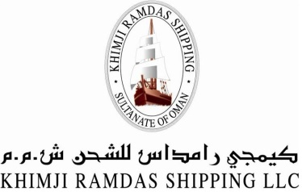
Khimji Ramdas partners in door to door delivery of RIG and Accessories
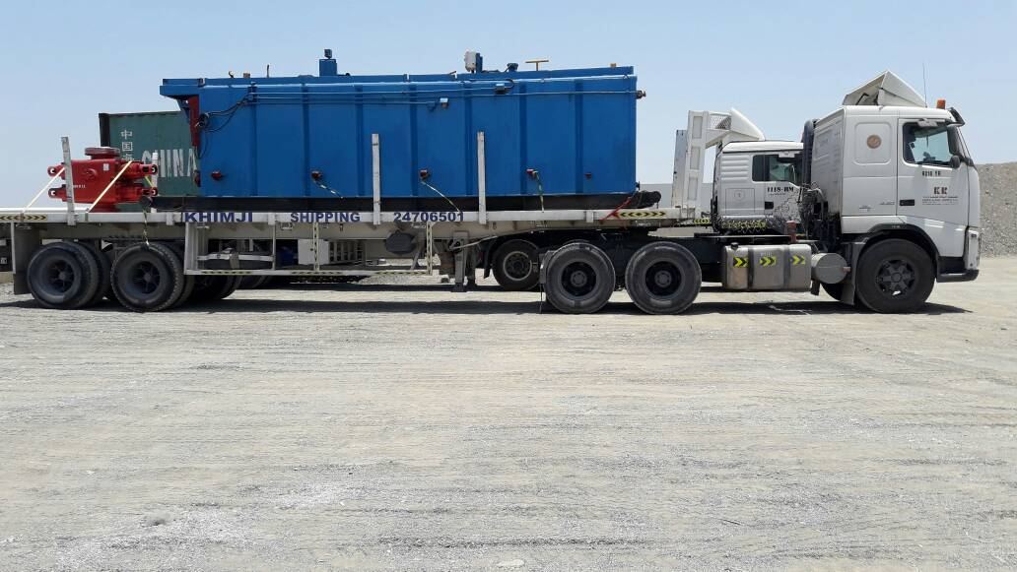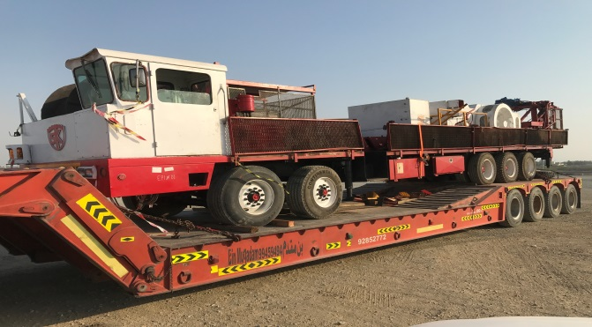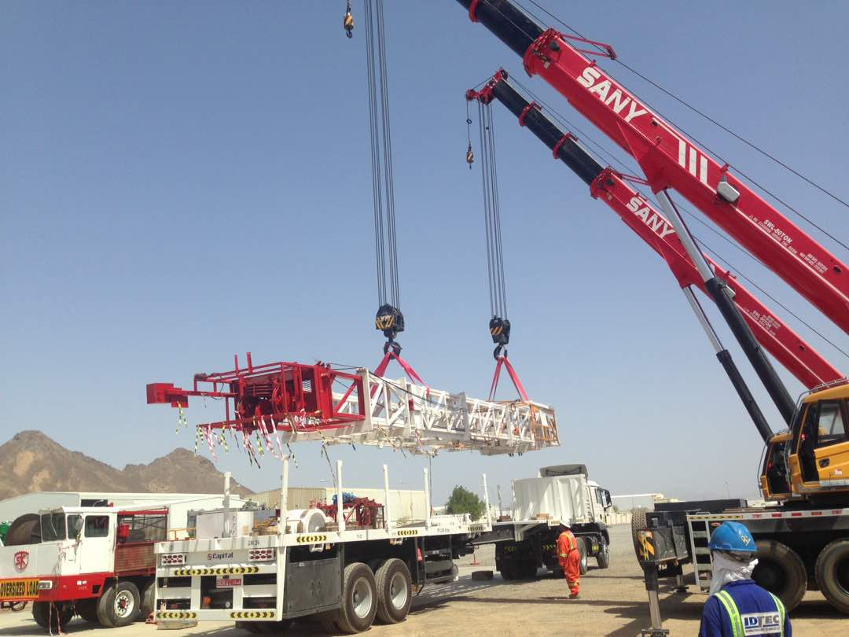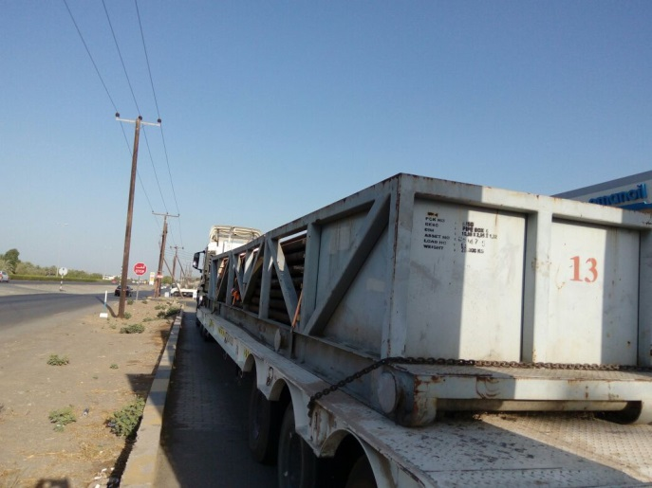

Case name : Rig Carrier / Rig Mast and Accessories
Load Port : Jakarta , Indonesia
Discharge Port : Sohar , Oman
Final Place of Delivery : Nizwa , Oman ( 350 kms away from Sohar)

Khimji Ramdas Shipping has successfully delivered RIG 106 carrier and its accessories to one of the major players in the Oil & Gas segment of Oman. The Rig and its parts were brought in from Indonesia on board a Multi Purpose Heavy Lift vessel(MPV) , self geared with 4 cranes of 32m/24m outreach . After discharge at Sohar Port in Oman the cargo was customs cleared and the ODC packages were successfully delivered to Nizwa around 350 kms away from the Port. Khimji Ramdas Shipping handled the entire critical part in the Oman leg – right from discharge of the cargo till final delivery .
The Rig Carrier , on wheels with dimensions of 1542 X 270 X 310 cm (25 tons) , and the Rig Mast , with dimensions of 1875 X 255 X 160 cm (18 tons) were the most critical parts , not only in terms of being ODC but also in terms of the sensitivity to the whole package. The heaviest pieces were the 2 nos of pipe boxes weighing 36 tons each (dimensions 1088 X 295 X 125 cm).
Three numbers of 100 ton Low bed – carrying the Rig Carrier and the two Pipe Boxes , one 18mtr long flat bed – carrying the Rig Mast and six numbers of 12 mtrs long ( and 3 mtr wide ) flat beds were used to transport the components to Nizwa . The dispatch from port and the offloading operations at site were handled with 100 ton cranes. The in gauge components were carried in 12 mtr flat beds. A total tally of 13 trailers , were used in the whole project. Traversing the distance of 350 kms , through the city limits of Sohar , Muscat and Nizwa was the main challenge in the job. Inspite of all odds , the whole operation was completed within a span of just two days from customs clearance.
Khimji Ramdas Shipping LLC thanks all the Project stakeholders for providing this opportunity to deliver successfully , yet again.

Khimji Ramdas Shipping , Oman……….providing synergy to the growth movements in Oman.

